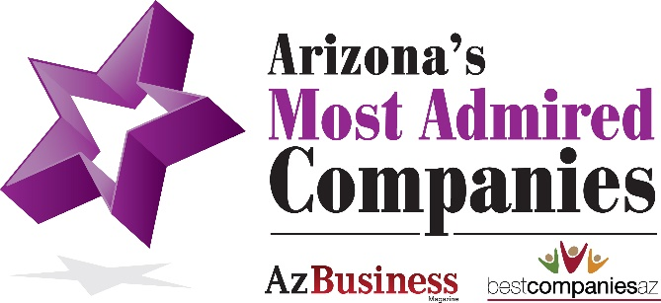

SAMPLE PRESS RELEASE PRE-EVENT

COMPANY named a 2023 Arizona Most Admired Companies winner
(for the ??? consecutive year (if applicable).

PHOENIX, AZ (Date) – BestCompaniesAZ and Az Business magazine recently announced that COMPANY NAME has earned a spot on the 14th annual Arizona’s Most Admired Companies list (for the ??? consecutive year (if applicable).

Arizona’s Most Admired Companies are evaluated by a panel of judges based on how a company has performed in the following five pillars: Workplace Culture, Leadership Excellence, Corporate and Social Responsibility, Customer Opinion and Innovation.

"Arizona’s Most Admired Companies is the most comprehensive and prestigious corporate awards program in the state because winners must demonstrate excellence in all five pillars. It identifies the vast contributions and impact the Most Admired Companies bring to our state,” says Denise Gredler, Founder and CEO, BestCompaniesAZ and co-founder of the Most Admired Companies program.
Michael Gossie, Editor in Chief at Az Business Magazine, adds, “The qualities recognized by Arizona’s Most Admired Companies program are the characteristics that build great companies. The companies honored with this award truly represent the best of the best in Arizona.”

Custom para from company CEO…..mention the pillars??
The 50 Arizona Most Admired Companies will be honored at an awards ceremony 5:00-8:30 p.m. Thursday, October 5, 2023 at Chateau Luxe, at 1175 E. Lone Cactus Drive, Phoenix, AZ 85024. The Most Admired winners will be featured in the Arizona Business Magazine Sept/October issue and online at BestCompaniesAZ.com.

For complete details visit www.yourwebsite.com or https://bestcompaniesaz.com/arizona-most-admired-companies/

To see the complete list of winners, click here.
About Your Company

About AZ BIG Media
For more than 35 years, AZ Big Media has been bringing readers the state's most compelling business, real estate and lifestyle news through the print editions of Az Business and AZRE magazines, Ranking Arizona, Az Business Leaders, Experience AZ, People & Projects to Know, Arizona Business Angels and Play Ball, the only official spring training publication of The Cactus League. The company’s news website — azbigmedia.com — serves as a complement to its print publications and incorporates up-to-the-minute breaking news, compelling business stories, C-Level executive editorial profiles and much more. Additionally, AZ Big Media's social media following is interested and engaged, and provides additional opportunities for news to be read, shared and discussed.

About BestCompaniesAZ
Founded in 2002, BestCompaniesAZ pioneered the intersection of recruiting, human resources, marketing and public relations — today known as Employer Branding or “PR for HR.” BestCompaniesAZ has evolved into an exclusive, niche PR, marketing and employer branding firm that specializes in building and promoting strong employer brands. BestCompaniesAZ is best known for establishing large-scale workplace awards programs and events, including the Best Places to Work in the Valley, Arizona’s Most Admired Companies, Top Companies to Work for in Arizona and several large-scale events designed to support Arizona veterans and spouses and diversity and inclusion.

