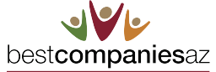
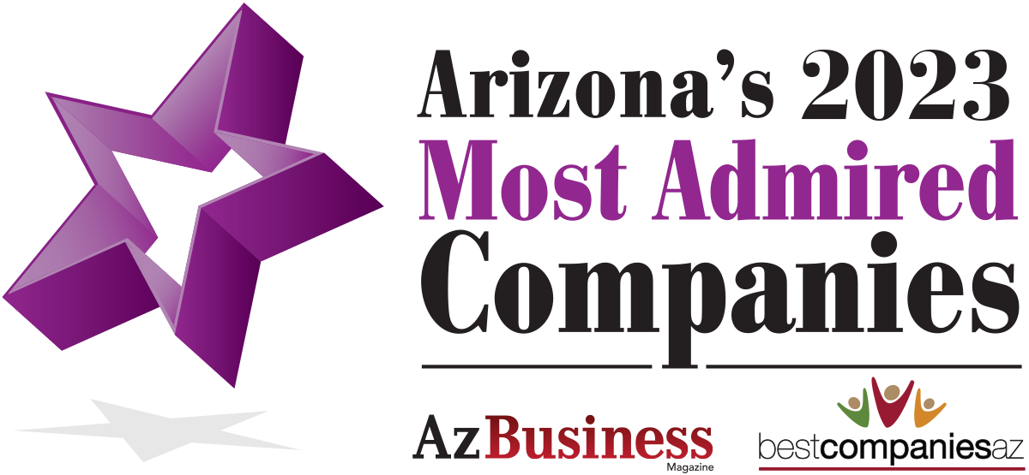

Exclusive Winner Invitation

Elevate Your Employer & Corporate Brand with BestCompaniesAZ

Featured Benefits Include:
- 1 Page Company Profile – company description, 1 photo, 1 video, MAC highlights, links to web/social channels, listing of all awards (sample)
- Featured on Best Employers page (view)
- Featured on MAC Award Page (logo/link - view)
- Featured in BCAZ Enews and Social promotional campaign (monthly) **special MAC winner promotion Sept and October
- Access to Promotional Toolkit including tips and sample press release
- Podcast Opportunity with Great Companies Great Leaders or other podcast host TBD (fee paid by BCAZ)
- Receive quarterly communications on upcoming awards, DEI opportunities and networking events with BCAZ partners
- Discount rate to upgrade to for BCAZ’s Annual 2024 Employer Branding & Talent Sourcing package (Gold & Silver Packages – link here)
- Virtual Career Event - Opportunity to participate in virtual career event (if available for your industry)

MAC Introductory Offer – 6 Month Trial
Hear what our clients have to say!

“BestCompaniesAZ is a top driver of traffic to our career website and has generated the 6th highest number of viewers beating many national and local branding platforms such as Glassdoor, Indeed, Yahoo, Recruit Military, Phoenix Business Journal, ZipRecruiter, local media channels, chambers, and more.”
Additional Client Testimonials (click here)
Investment: $4,500 per quarter*
*15% discount to upgrade to 2024 Silver or Gold Package
YES, Sign me up for the BCAZ Annual Branding Package

Company Name: _____________________________________
Signature: __________________________________________

Date ________________

Why BestCompaniesAZ
- WE BOOST YOUR ONLINE VISIBILITY quickly on the #1 ranked website – BestCompaniesAZ.com
- WE PROVIDE 3RD PARTY ENDORSEMENT shining a spotlight on your dynamic culture and awards!
- WE ELEVATE & STRENGTHEN your regional brand attracting the best talent, customers and community partners!
- WE OFFER EXCLUSIVITY among an elite group of award-winning companies!
- WE PROVIDE A POWERFUL NETWORK of regional media and community partners who extend our reach!
- WE SAVE YOU MONEY & TIME by consolidating your employer and corporate branding strategies!

